**2024 Diversity, Equity, and Inclusion Survey**

*Submitted by TAA’s Committee for DEI, January 2025*

### **Introduction**

* **Background**:
  + In August of 2020 TAA launched its first diversity survey to learn more about the experience and needs of its members with respect to diversity, equity, and inclusion (DEI). One of the outcomes of this first survey was the formation of the committee on diversity, equity, and inclusion (CDEI) which then took on the work to analyze the survey. This initial survey noted the following recommendations based on the needs of TAA members: they would like opportunities for DEI-related professional development and they would like DEI-related engagement opportunities. The report also provided the following recommendations for things TAA could do to support DEI work. These represent areas for growth for TAA and include making substantial changes to reflect DEI goals in its mission. It was recommended that TAA diversify both leadership and membership and provide tangible, physical resource to the members to inform their work. The full report published in October of 2021 can be reviewed at the [website](https://taaa.memberclicks.net/assets/DEIresources/TAA%20Survey%20Analysis%20Report_FINAL10.22.21.pdf).
  + The 2024 survey was conducted in an effort to understand whether the interests of the members have shifted or remained similar since the 2020 survey.
* **Methodology**:
  + The CDEI examined questions from the 2020 survey keeping some questions identical for a direct comparison while modifying other questions. The second TAA diversity survey was launched Feb. 1, 2024. Reminders were sent approximately monthly via email to members to encourage participation. A QR code was briefly shared on a slide during the conference. The last survey was completed on 5/30/24. Responses that came from the same IP address were examined for completeness. When responses were identical, the incomplete survey was removed from the data set. When responses were from the same IP address and were different, they were both counted. The decisions on the responses to keep were ultimately made by the quantitative analysis team. After reviewing the responses the team identified 105 valid responses. The qualitative team had two coders and identified the questions that were qualitative in nature as (Q24), (Q25), (Q15), (Q20), (Q13), (Q9), (Q26), (Q22), and (Q23). The quantitative team split up the remaining questions for analysis.

### **Findings**

**Participant Demographics.**

Refer to Figures at the end of this document for more information.

* **Geographic distribution:**
  + Almost all participants were from the U.S. (96%) and were fairly evenly distributed across the U.S with the smallest group from the Midwest. (Fig. 1.)
  + TAA has members in every state except for Alaska and Nebraska. The states with the highest number of members are Texas (700), Utah (374), New Mexico (315), New York (293), Oregon (277), Florida (215), New Jersey (201), and North Carolina (164). If you consider TX, NC, and FL in the Southeast, this represents one third of the membership. Other than California (81), Pennsylvania (98), and Ohio (50), no other state exceeds 30 members. About 50% of states have less than 15 members. Less than 1% of the membership is international. Canada has the most with 10, followed by the UK with 4.

**Race/ethnicity and gender demographics:**

* + The largest demographic group was White or Caucasian with almost two thirds (64%) of participants. Almost a quarter of participants identified as Black or African American (14%) or Hispanic or Latin X (9%). Less than 10% of participants identified as American Indian or Alaska Native (3%), Asian (2%), or Middle Eastern or North African (2%) (Fig 2).
  + There were twice as many participants who identified as Female (64%) than Male (31%) with 1% identifying as Non-Binary (Fig. 3).
  + TAA does not collect information on race/ethnicity or gender of its members.
* **Author status demographics:** 
  + Of the 86 people sampled, 56 (65%) identify as being academic authors while 55 (55%) identify as being textbook authors. Note that there is overlap between the two types of authors as some identified as being both textbook and academic authors.
  + A third of participants reported to be both textbook and academic authors, 28% reported to be solely textbook authors and 19% reporting as solely academic authors. 17% of participants reported that they are aspiring academic and/ or textbook authors (Fig. 4).
  + During the time of the survey TAA had about 3,000 members. Approximately 70% of the membership are published authors.

**Quantitative Highlights**

* **DEI and TAA Resources**
  + Half of respondents were NOT aware of TAA’s Resources for Diversity, Equity, and Inclusion for authors (https://www.taaonline.net/diversity-equity-and-inclusion-resources).
  + The most highly rated DEI resource request was a “A guide on how to represent diversity in your writing” (2.4/9) with the other resources rated in the middle in descending order (Guidelines for discussing diversity issues with publishers, editors, and co-authors”, Understanding the multiple facets of accessible writing, Best practices for reviewers in analyzing diversity issues in works they review, How to best source and use diverse imagery and illustrations, Understanding bias in authoring and publishing, List of diversity experts or diversity reviewers that can be called on by TAA members, Information on inclusive pedagogy and curriculum). The lowest rated DEI resource was Incorporating triggering sensitivities in your content.

**Qualitative Highlights**

1. **Resources for DEI**:
   * Ten mentions emphasized the importance of DEI-related resources, such as guides and tools to support authors. Respondents highlighted the need for practical resources, including guides for incorporating diversity in writing, best practices for reviewers, and structured frameworks.
   * **Meaning**: There is a strong demand for tangible, actionable resources that authors can use to navigate DEI challenges in their work. These tools are seen as critical for fostering inclusivity in academic and textbook authoring.
2. **Diversity in Authoring**:
   * There were seven mentions underscoring the need for greater integration of diverse perspectives in authoring. Participants frequently cited the importance of incorporating cultural considerations and diverse voices in their writing.
   * **Meaning**: Authors are committed to fostering representation and inclusivity in their work. However, the ongoing focus on diversity suggests that systemic barriers still exist and require continued organizational support.
3. **Inclusive Language Practices**:
   * There were two responses that focused on the challenges of inclusive language. Respondents identified difficulties with terminology, citing evolving language standards and inconsistent guidance.
   * **Meaning**: While inclusive language is a cornerstone of DEI, the challenges suggest a need for clearer guidelines and training to help authors navigate this complex area.
4. **Equity in Opportunities**:
   * There were three responses that addressed broad concerns about equity. Specific references to systemic inequities, including hiring discrimination, lower salaries, and identity-based limitations in authoring opportunities, were noted.
   * **Meaning**: Equity concerns remain a critical area of focus, reflecting broader systemic challenges within academia and publishing. Advocacy and targeted interventions by TAA could address these disparities.

**5. Training and Development Needs**:

* + There is a demand among the survey respondents for DEI-related resources. Respondents explicitly requested workshops, training sessions, and professional development opportunities.
  + **Meaning**: Structured learning opportunities are crucial for equipping authors with the skills and knowledge to incorporate DEI principles effectively into their work.

### **Implications**

* **For TAA**:
  + Explain how findings inform TAA’s strategic priorities, such as creating resources, fostering collaborations, and expanding DEI training.
  + From the Quantitative Analysis:
    - There is a need to discuss TAA membership demographics and how to create a model that better serves a broader population of textbook and academic authors. The Council/ Board can indicate this robust commitment with clearly stated DEI values in the Mission and Vision statements.
* **For Members**:
  + Discuss how TAA will address systemic barriers to support underrepresented members.
  + We need to have a firm commitment to TAA members to support their DEI needs in authoring and a plan to get current TAA DEI resources more widely distributed to members through regular blog and newsletter items on individual topics. The survey committee is taking this to the DEI committee to create a plan for this with a schedule. The web site materials are currently under review and revision to make them more visible and accessible to TAA members.

### **Recommendations**

Provide a detailed action plan based on the findings. Organize recommendations by priority and feasibility:

1. Short-Term Actions (e.g., develop DEI guides, schedule workshops).
2. Medium-Term Actions (e.g., engage publishers, establish affinity groups).
3. Long-Term Goals (e.g., diversify leadership, track progress annually).

### **Conclusion**

* Reiterate TAA’s commitment to advancing DEI in textbook and academic authoring.
* Invite members to collaborate in future DEI initiatives.

**Demographic Figures**

**Figure 1.** Survey Participant Geographic Distribution

**Figure 2.** Survey Participant Race/Ethnicity Distribution

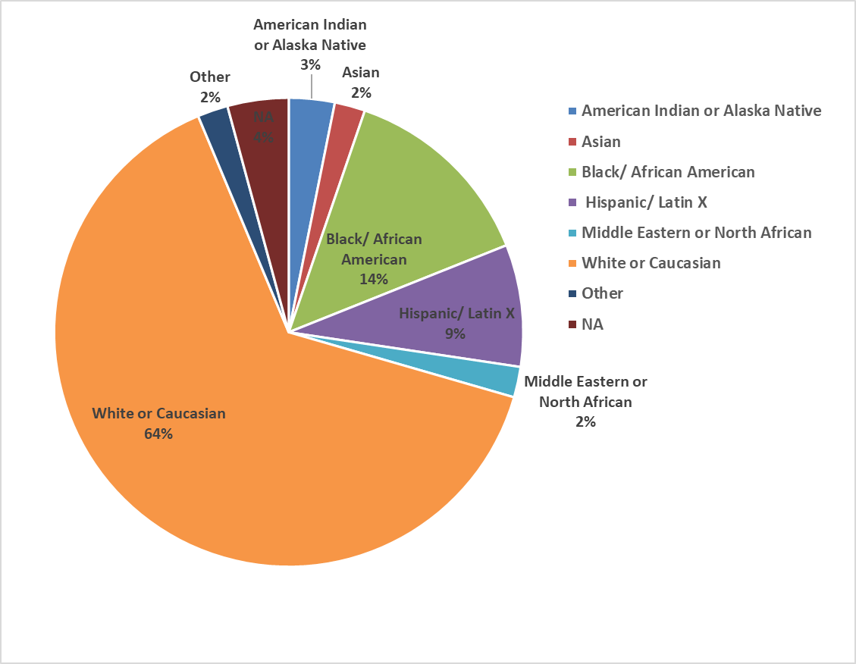

**Figure 3.** Survey Participant Gender Distribution

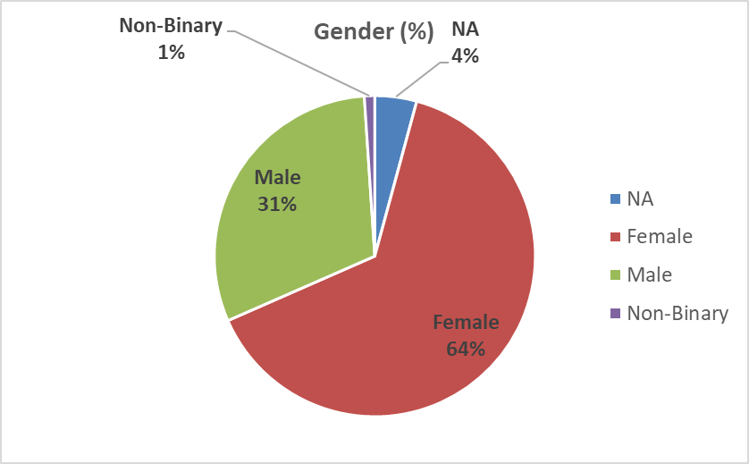

**Figure 4**. Survey Participant Authoring Experience

